WAED SALEM SHAMAILEH
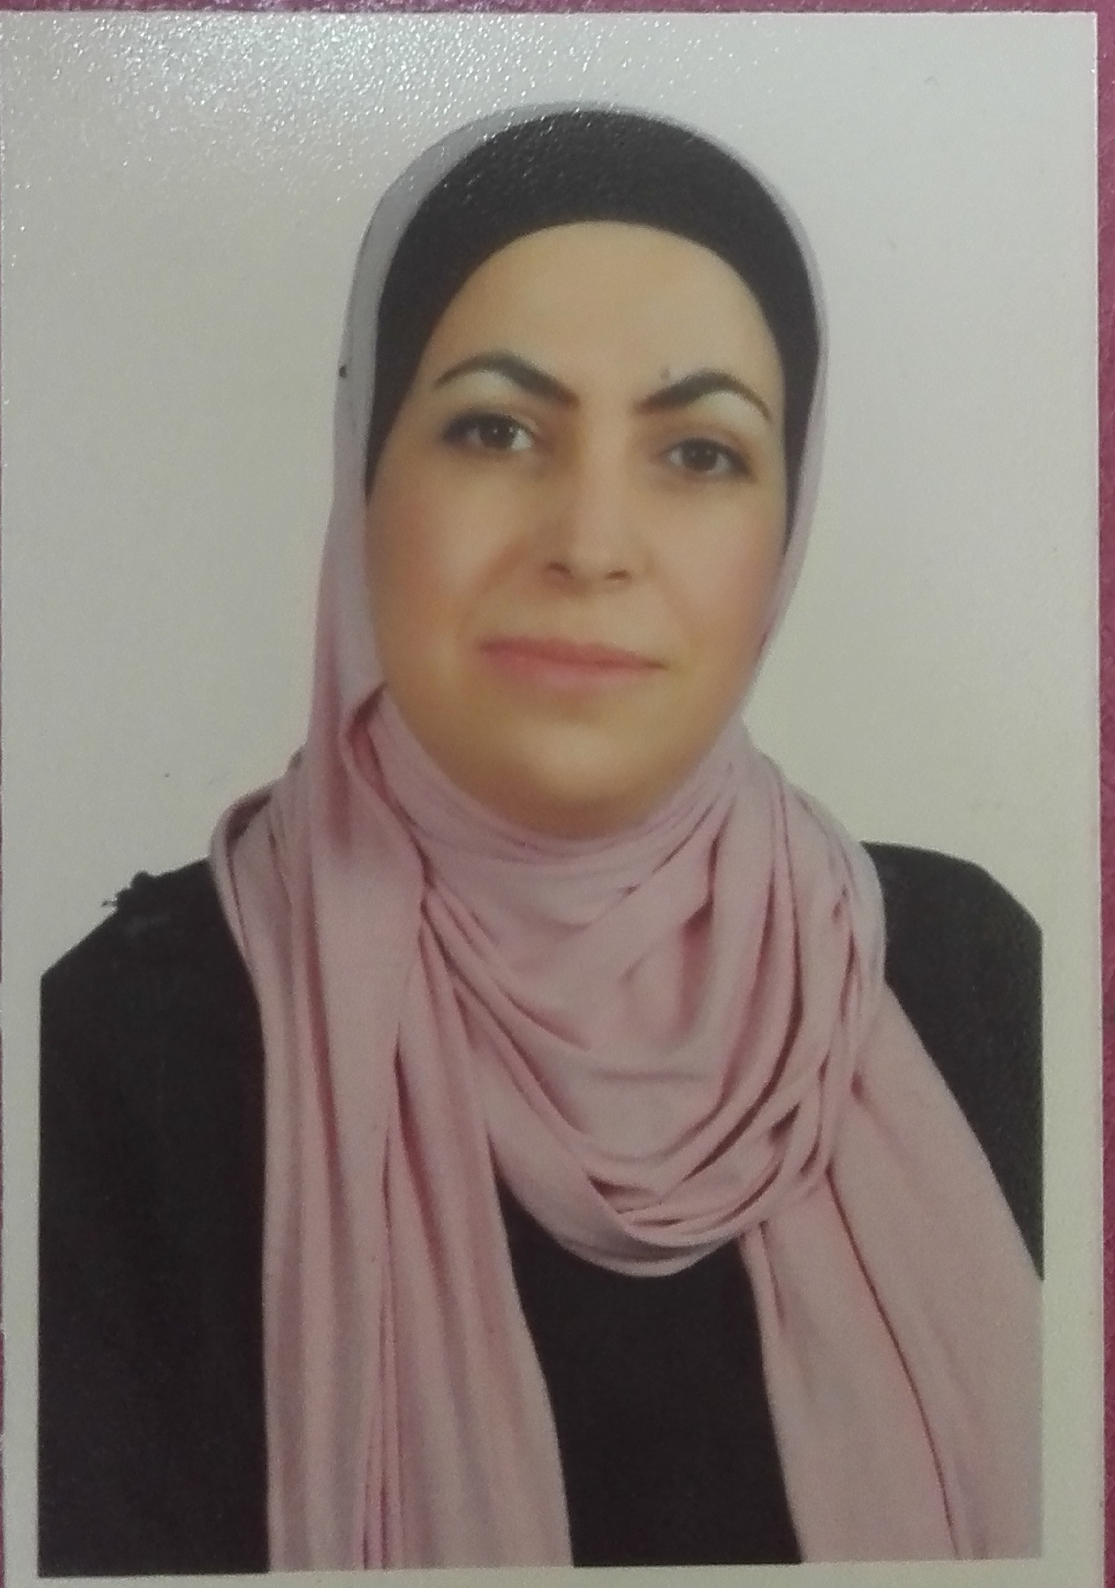
Personal Information
Nationality: Jordainan
Social status: Married
Place of residence: Karak-Jordan

Educational Qualifications
- Master degree in Biology from Mu'tah University.
Thesis:" Effect of Wastewater Treatment on the Bacterial Quality and Quantity at Mu'tah University Plant"
- Bachelor's degree in Biology from Mu'tah University.
Experiences:
- Working in Mu'tah university as lecturer since feb.2015 up to date.
- Working in Mu'tah university as teaching assistance since Agu.2005 Up to 2015.
Courses
- Microbiology
- Microbiology for nursing students
- Introduction to ecology
- Biology 101
- Embryology
Practical ( laboratories)
- Practical Microbiology Practical Biology 105
- Practical Invertebrates Practical Animal physiology
- Practical Genetics Practical Hematology
- Practical Medical Analysis Practical Plant Biology
- Practical Plant physiology Practical Biology 106

Mobile Number: 0795194643

Email:waadwater1@yahoo.com

